|  |  |
| --- | --- |
|  | AUSTRALIAN HIGH COMMISSION  DHAKA |

***Press Release***

**Minister Collins leads Australian delegation to Bangladesh for 10th Commonwealth Women’s Affairs Ministers Meeting**

Australian Minister for the Status of Women, the Hon Ms Julie Collins MP, led a delegation to represent Australia as Commonwealth Chair-in-Office at the 10th Women’s Affairs Ministers Meeting (WAMM) in Dhaka on 17-19 June 2013.

Ms Collins said the meeting provided a vital opportunity for Commonwealth nations to discuss gender issues and strategies to advance the status of women.

“Building strong partnerships with other countries is vital in our quest to expand economic opportunities for women and increase women’s participation in politics and civil life,” Ms Collins said. “Global alliances and international gatherings like 10WAMM help ensure we are working together to driver real change.”

In a keynote address to Commonwealth Business Council’s Special Forum on Women’s Economic Empowerment, Ms Collins spoke about the Australian Government’s commitment to gender equality and the importance of women’s social and economic participation in the fast-moving global environment of the 21st century.

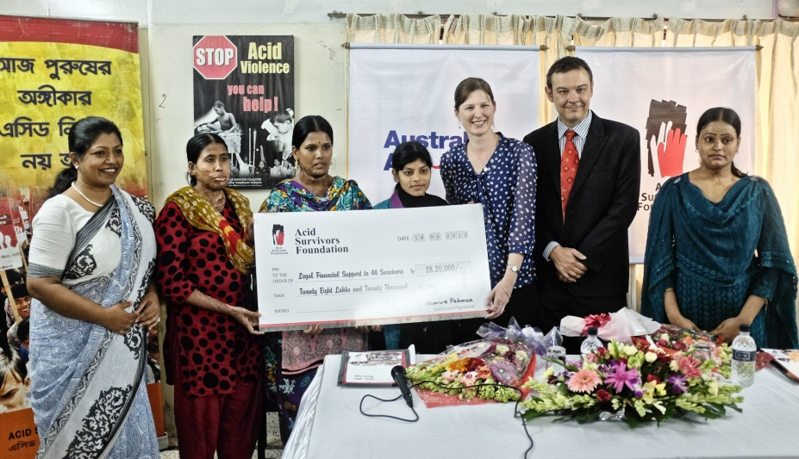

*The Hon Julie Collins MP (3rd from right) handing out stipends to cover costs associated with legal proceedings to representatives of acid survivors, with Acting High Commissioner of Australia, Mr Tim Bolotnikoff and ASF Executive Director, Ms Monira Rahman*

While in Dhaka, Ms Collins also visited the Acid Survivors’ Foundation (ASF). Australia has provided AUD $1.2 million to the Acid Survivors’ Foundation since 2011.

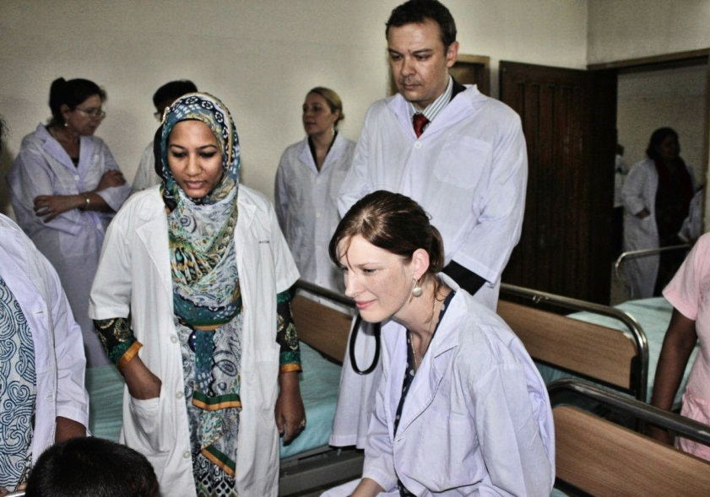

*Minister Collins and Acting High Commissioner, Tim Bolotnikoff, speaking to acid attack survivors during a visit to the Acid Survivors’ Foundation’s Hospital*

“This funding supports a burn care service for victims of acid attacks and provides legal and rehabilitation services to the survivors, the majority of whom are women. It also supports ongoing efforts to prevent gender-based violence,” Ms Collins said.

Ms Collins said Australia has a strong role to play internationally in preventing gender-based violence and advancing gender equality.

“The Australian Government is committed to ending violence against women and girls and understands that to make a real and sustained difference, governments across the Commonwealth must work together,” Ms Collins said.

A full transcript of Minister Collins’ speech at 10WAMM is available at <http://juliecollins.fahcsia.gov.au/node/372>.

**Australian High Commission, Dhaka**

**19 June 2013**

For further information please contact:

Senior Research and Communications Officer, AHC Dhaka

Tel: 8813105 (413)

E-mail: simeen.sabha@dfat.gov.au